 **20 Mar 2015** **The Weekly Bulletin of Rotary Club of Kathmandu Mid-Town** **bc-36/3.015**

|  |
| --- |
|  |

District: 3292 Web:www.rotarymidtown.org.np Club Id: 26776

**MARCH IS THE LITERACY MONTH**

**“Literacy is a platform for democratization,**

**and a vehicle for the promotion of cultural and national identity.”** *- Kofi Annan*

Club’s Weekly Meeting # 1270 on Friday, 13 March:

Extracts of the Minutes :

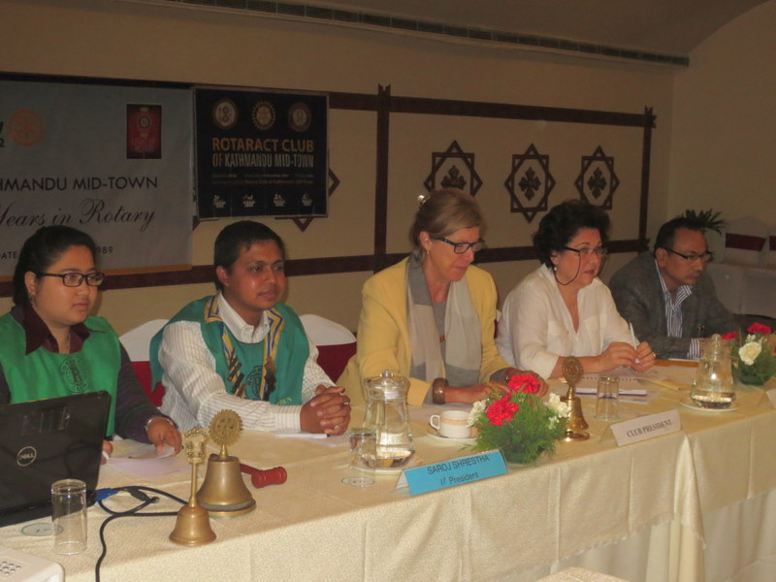

“1. RC KTM Mid-Town 2nd VP Lisa called Joint Meeting #1270

with Rotaract Club of Kathmandu Mid-Town to order.

“3. 2nd VP Lisa welcomed welcomed members and guests.

Mr Durga Aran (Chair 1st Steps Himalaya), Rtn David

Sowerwein and Heidi (RC Woodside Portola Valley),

Rtn Isabelle Jacob (RC Antwerp, Belgium) and the family

of late PP Giri Manandhar (Lochan and his 3 daughters),

and Sumitra Manandhar, Rtn Jay (Bruno) Malla (son of

late PP Pratap who is now a Rotarian with RC San

Francisco Evening Club) and ten Rotaracts.

“4. Rotaract Club of KTM Mid-Town Sujan Manandhar called

RC KTM Rotaract meeting # 455 to order.

“7. Celebration of ROTARACT WEEK. Rotaract Pres Sujan

Manandhar gave an action-packed PowerPoint

presentation summarizing what Mid-Town Rotracts had

done to date during the 2014-15 Rotary year. The 54

member strong Rotaracts actually have 24 female members and only 20 male members – they are looking to even out the numbers. He summarized in words as well as photos the multitudinous activities that they have been involved in with community service, avenues of service, celebrating festivals and other good deeds. VP Lisa thanked them for their presentation and applauded their good works. Visiting Rtn Isabelle Jacob (herself a former Rotaract from Belgium) expressed her appreciation of their good works and said that she would try to put them in touch with Rotaracts in Belgium. Rtn Shristi gave the vote of thanks.

“10. 2nd VP Lisa welcomed the Mr Durga Aryan Chair of 1st Steps Himalaya and the final check of MG 77952 was handed over to him. Mr Aryan thanked RC Mid-Town and RC Auld Meldrum (Scotland) for their kind help. He welcomed everyone to Sindupulchowk on Friday 20 March to see that work that has been taking place at the school and the construction of the training centre. PP Ajay is organizing transport to Sindupulchowk – if you are interested in attending please contact him.

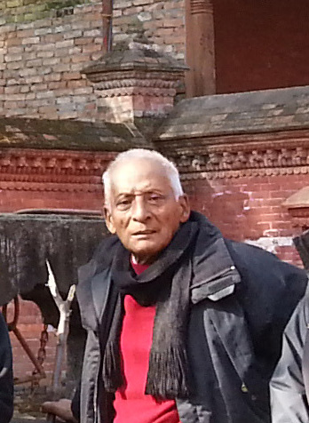

“11. 2nd VP Lisa asked PP Ambica to lead a remembrance of late PP Giri. Rtn Rabi ran a slide show

on the life of late PP Giri that had been assembled by his wife and daughters. Mid-Towners

shared happy memories and told touching stories of a very good-humoured, happy, and generous

man whose life had been enriched by his work, his family, his love of sports and his commitment

to Rotary. PP William read from Jules Verne`s Around the World in 80 Days.

Here are a few statistics on the life of PP Giri: DoB: 26 Aug 1937, Address: Ganabahal,

Kathmandu, Ward # 22, Education: [B.SC](http://b.sc/), B.A., SLC (1951). Occupation: 1. Chairman, Simca

Laboratory Pharmaceutical Company; 2. Librarian/Functional Officer, British Council 1957-1967; 3. Country Manager, Hoechst Nepal 1967-1987. Interests:1. Poetry, 2. Social work, 3. Sports - football, table tennis, cricket, billiards (national champion for a number of years). Memberships: 1. Life member - Himalayan Amateurs Dramatic Society (HAMS); 2. Past President and Trustee - Nepal Britain Society; 3. Past President - Rotary Club of Kathmandu Mid-Town 1999-2000; 4. Founder Vice President - Shanti Nikunja Alumni Association; 5. Life member - Cancer Relief Society; 6. Life member - Nepal Council for World Affairs.

”12. Information sharing:

> Reminder: Mid-Town Pot Luck Dinner on March 28, 2015 at the home of Rtn Sheri.

> Rotary Youth Leadership Awards (RYLA) 30 March-2 April --develops leadership 18-23 year olds.

> Preparations for the RI Convention in Rio – early registration ends March 31; sign up now

> PP Komal conveyed a message from PP Iswar (RC Patan) for a program by Dr. Bibek Pradhan at the joint meeting is finalized on 24th March (Tuesday) at RC Kantipur @ Hotel Sankar @ 5:30 pm.  You are requested to confirm to President Uttam Bhattarai 9851020613 regarding your club's participation so that Rtn. Uttam is enable to arrange for high tea which costs Rs. 700/-.

> Rtn Bruno Malla extended an invitation for lunch on the occasion of the second year death anniversary of PP Pratap:

> FYI - update on the recent District Conference by the Conf Chair.

> Information from PDG Ratna Man Shakya on Polio update

“9. Statistics of the meeting: Members present: 25; Rotaracts 10 and guests 10”.

# Weekly Meetings and Programs :

|  |  |  |
| --- | --- | --- |
| Date | Program/ Speaker | Topic of Presentation |
| 20 March | Dr Rup Khadka | Nepal tax system |
|  |  |  |

Weekly Meeting on Friday, 20 March:

Our guest speaker will be Dr Rup Khadka who will give a talk on Nepal tax system.

Rup Khadka who joined government service in 1980 after his MA Economics, as Tax Officer, is an expert in the development and implementation of tax policy, tax legislation, tax administration and inter-governmental fiscal relations. He has over 25 years of experience in VAT, income tax, excise duties, customs duties, property taxes, inter-governmental fiscal relation, tax laws, tax regulations, tax procedures, tax administration, capacity building, and taxpayer education. He has published many articles in national/international journals and published several books.

Chairman, High Level Tax System Review Commission appointed by the Government of Nepal, 17 Nov 2014 to date

Senior Tax Collection Advisor, Deloitte operated USAID funded Economic Governance Project in South Sudan, March 1, 2010 to April 30, 2013

Senior Tax Advisor, Deloitte operated USAID funded Strengthening Core Economic Governance Institutions in South Sudan II (CORE II) Project, May 1, 2013 to October 16, 2014

Senior Tax Policy and Administration Advisor,Bearing Point operated USAID funded Economic Reforms to Enhance Competitiveness Project, Central Asian Republics, Tajikistan, June 2008 to February 2010

Value Added Tax/Large Taxpayer Unit Advisor, Maxwell Stamp LLP operated DFID funded Reform in Revenue Administration Project, Bangladesh, August 2005 – April 2008

Training Advisor/Senior Consultant,Bearing Point operated USAID funded Afghanistan Economic Governance Project, November 2004 – July 2005

National Advisor, DANIDA/GTZ funded Revenue Administration Support Project, Nepal, January 1999 – October 2004

VAT Consultant, DANIDA funded VAT Project, Nepal, September 1997 – December 1998

Senior Project Advisor, USAID funded VAT Project, Nepal, April 1994 – August 1997

He did his Ph. D. in Taxation from Gokhale Institute of Politics & Economics, University of Poona, India, 1989.

**Mid-Town Potluck Dinner on Saturday, 28 March 2015**

**Venue: At Rtn Sheri’s House (adjacent to the British School in Kupondole)**

It’s a potluck party and we should have a lot of fun.

The organizers expect each Mid-Towner to sell at least 5 raffle tickets of Rs 500 each.

Many wonderful prizes to be won including Grand Prizes: 2 nights for 2 at Tiger Mountain Pokhara Lodge;

2 nights for 2 at Dwarika's Himalayan Shangri-La Village Resort and

airline ticket 'surprise' courtesy of Osho World Travel Nepal Pvt. Ltd

**Update on the recent District Conference by the Conference Chair**

Dear Rotarians,

It gives us an immense pleasure to apprise you that the 7th District Conference held on 27, 28th Feb. and 1st March in Chitwan was successfully concluded in the witness of more than 850 Rotarians & guests, with the different worthwhile resolutions tabled on as the stepping stones towards the betterment of community, nation and globe. The primary focus of this conference was to ‘Enjoy Rotary’ with humanitarian and community service such as Basic Education and Service, Disease Prevention & Treatment, Water & Sanitation, Economic & Community Development, Entrepreneurial Skill Development, Women Empowerment & Development and many more highlighting social issues. In the process of organizing this historic conference, your support and generosity were the main source of our inspirations. Without this, the conference would not be possible. Therefore, we, hereby, like to extend our sincere thanks and gratitude for your assistances in all the ways, making this conference memorable and productive.

Thanking for your kind cooperation in this regards and looking forward your support in the days ahead,

Yours in Rotary, Uttam Lal Chuke, Conference Chair

**Rtn Bruno Malla extended an invitation for lunch on Saturday 14 March**

He read invitation text already circulated by email by his mother Nabina Malla.

(Rtn Bruno is the son of late Pratap Malla)

Dear All,

Rotary Club of Kathmandu Mid-Town.

It will be two years on 14th March 2015 (as per the tithi, lunar calendar) that my husband Pratap Malla passed away.

I am requesting my near and dear ones to please attend a get-together program on that day to remember him and

pray for his eternal peace together.

Day/date:  Saturday, 14 March 2015

Venue:  191/43 Sangralaya Marg, Chhauni

Time:  1:00 PM

Then we will have lunch together in his memory.

You are cordially invited.

Nabina Malla

**Chair from living trees!**

Designer Werner Aisslinger unveiled a living chair at Milan Design Week 2015 recently, grown from the ground up instead of being produced in a factory. The green chair consists of a live plant that is growing in a specialized shape set by a steel mould. When the mould is removed, it leaves behind a naturally cultivated seat to perch upon. Aisslinger’s Chair Farm considers the way we consume furniture: instead of importing items for use, we can nurture and shape them ourselves and then harvest them locally instead of having them manufactured in a far-flung factory. The design minimizes resource use and waste, making it an exceptionally sustainable alternative to standard chairs. Aissllinger has been experimenting with advanced sustainable technology for years.

*Source: The Himalayan Times*

On Lighter Side:

A Question to God:

What surprises you most about the human being?

God’s answer:

That they get bored of being children, are in a rush to grow up, and then long to be children again.

That they lose their health to make money and then lose their money to restore health.

That by thinking anxiously about the future, they forget the present, such that they live neither for the present nor future.

That they live as if they will never die, and they die as if they never lived.

Travel / Tourism

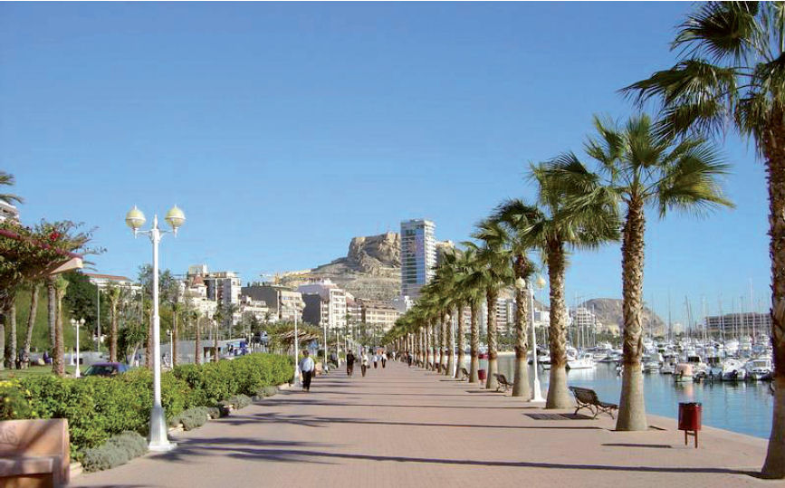

Travelling is a great fun.

**A THOUGHT FOR TODAY:**

**[The first to apologize is the bravest, the first to forgive is the strongest,](http://www.brainyquote.com/quotes/quotes/b/baruchspin101666.html" \o "view quote)**

**[and the first to forget is the happiest.](http://www.brainyquote.com/quotes/quotes/b/baruchspin101666.html" \o "view quote)**



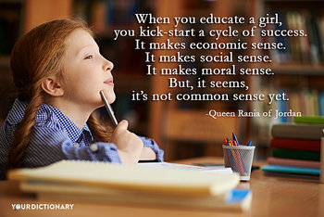

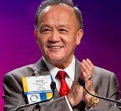

Share your Rotary stories. Tell them to your friends, on social media, and through

Rotary.org. Our Rotary stories are what inspire us, and what encourage others to join us;

they help light up our service, as we work to Light Up Rotary ?

**RI President GARY C.K. HUANG**

## 20 March 2015 The Weekly Bulletin of Rotary Club of Kathmandu Mid-Town bc-36/3.015

******************************************

Annex

Joint meeting photographs (Courtesy : Secretary Isabella Khadka)

